**POWER BI TASK 1**

**NAME:** S.MADHUMITHA

1. TO EXTRACT GIVEN CSV TYPE DATA

STEPS: get data-> text/csv ->select file and open -> click transform data.

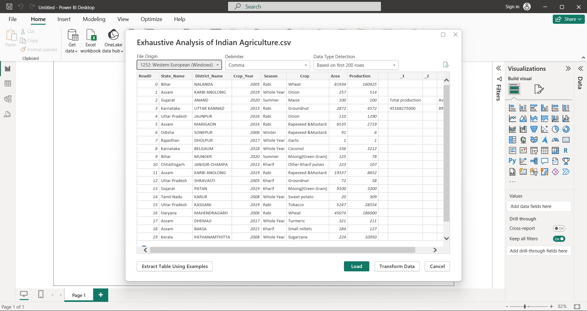

THE DATASET HAS BEEN EXTRACTED.

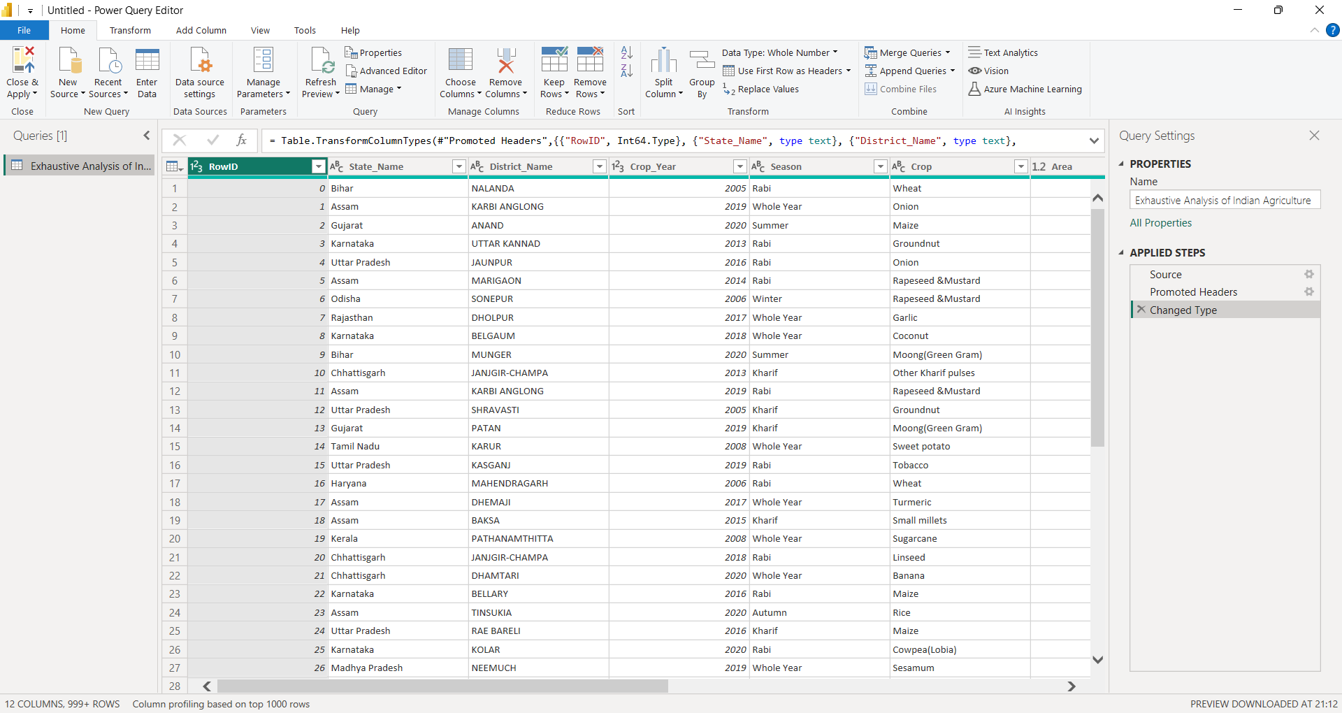

2. TO REMOVE UNNECESSARY COLUMN:

STEPS: select the column that needed to be deleted -> right click ->click remove.

TO UNDO: click the remove option from the applied steps at the right side of the screen.

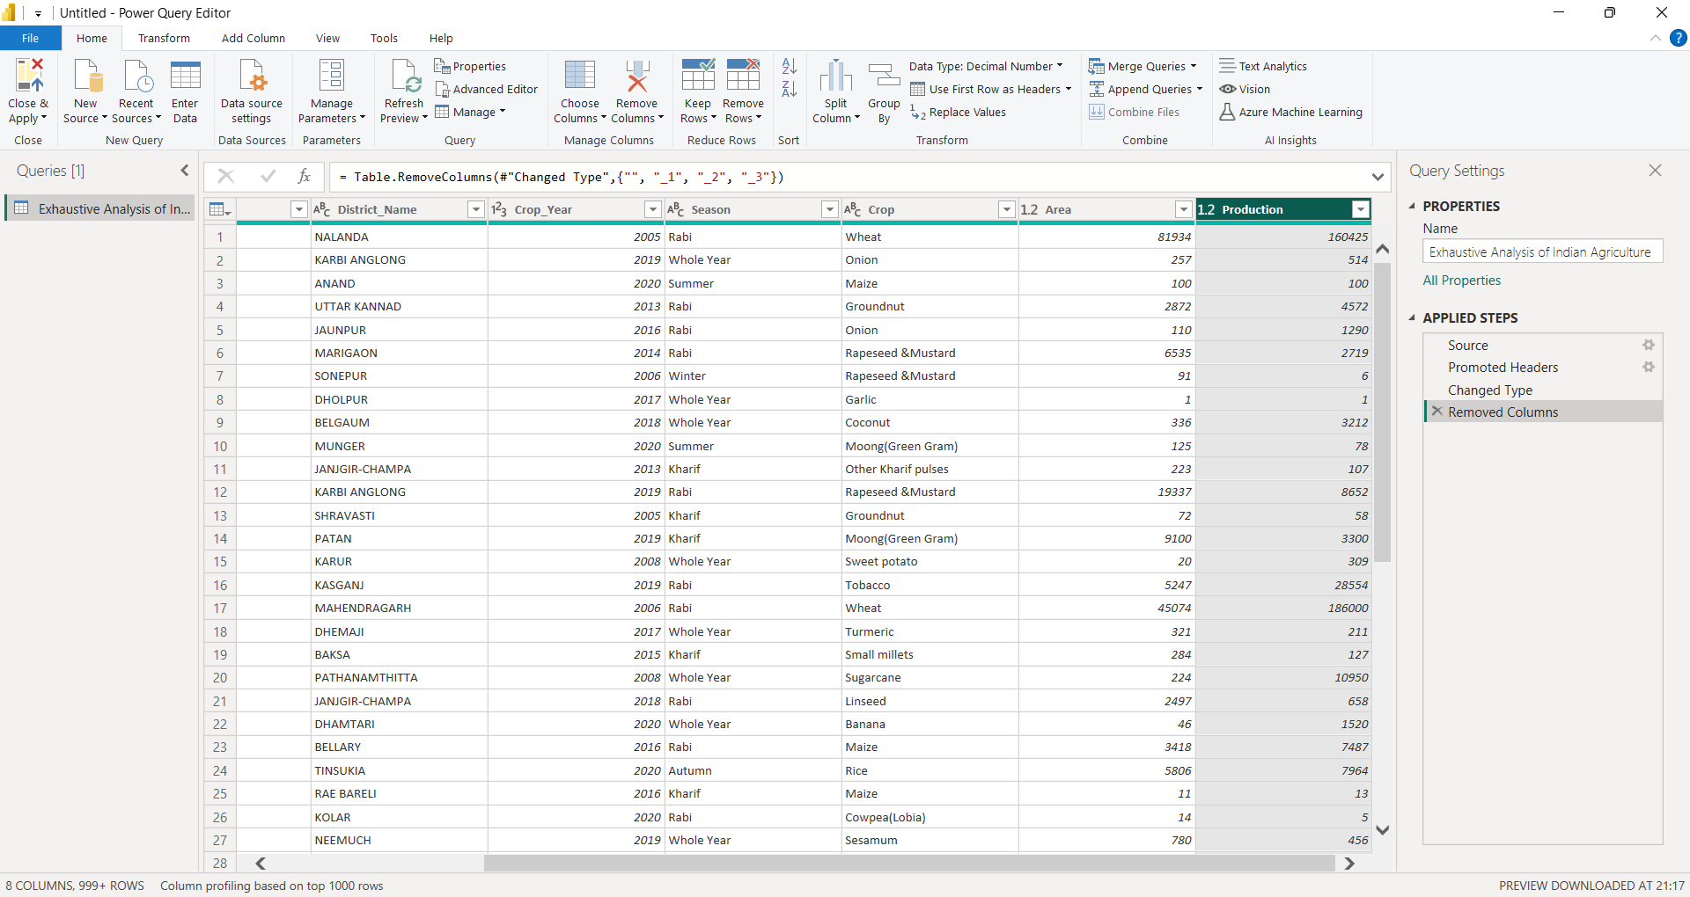

3.HOW TO CHECK THAT THE DATA HAS ‘NULL’ VALUES:

STEPS: click “view” -> select column quality.

IF WE HAVE NULL VALUES, click “remove rows” -> click appropriate options.

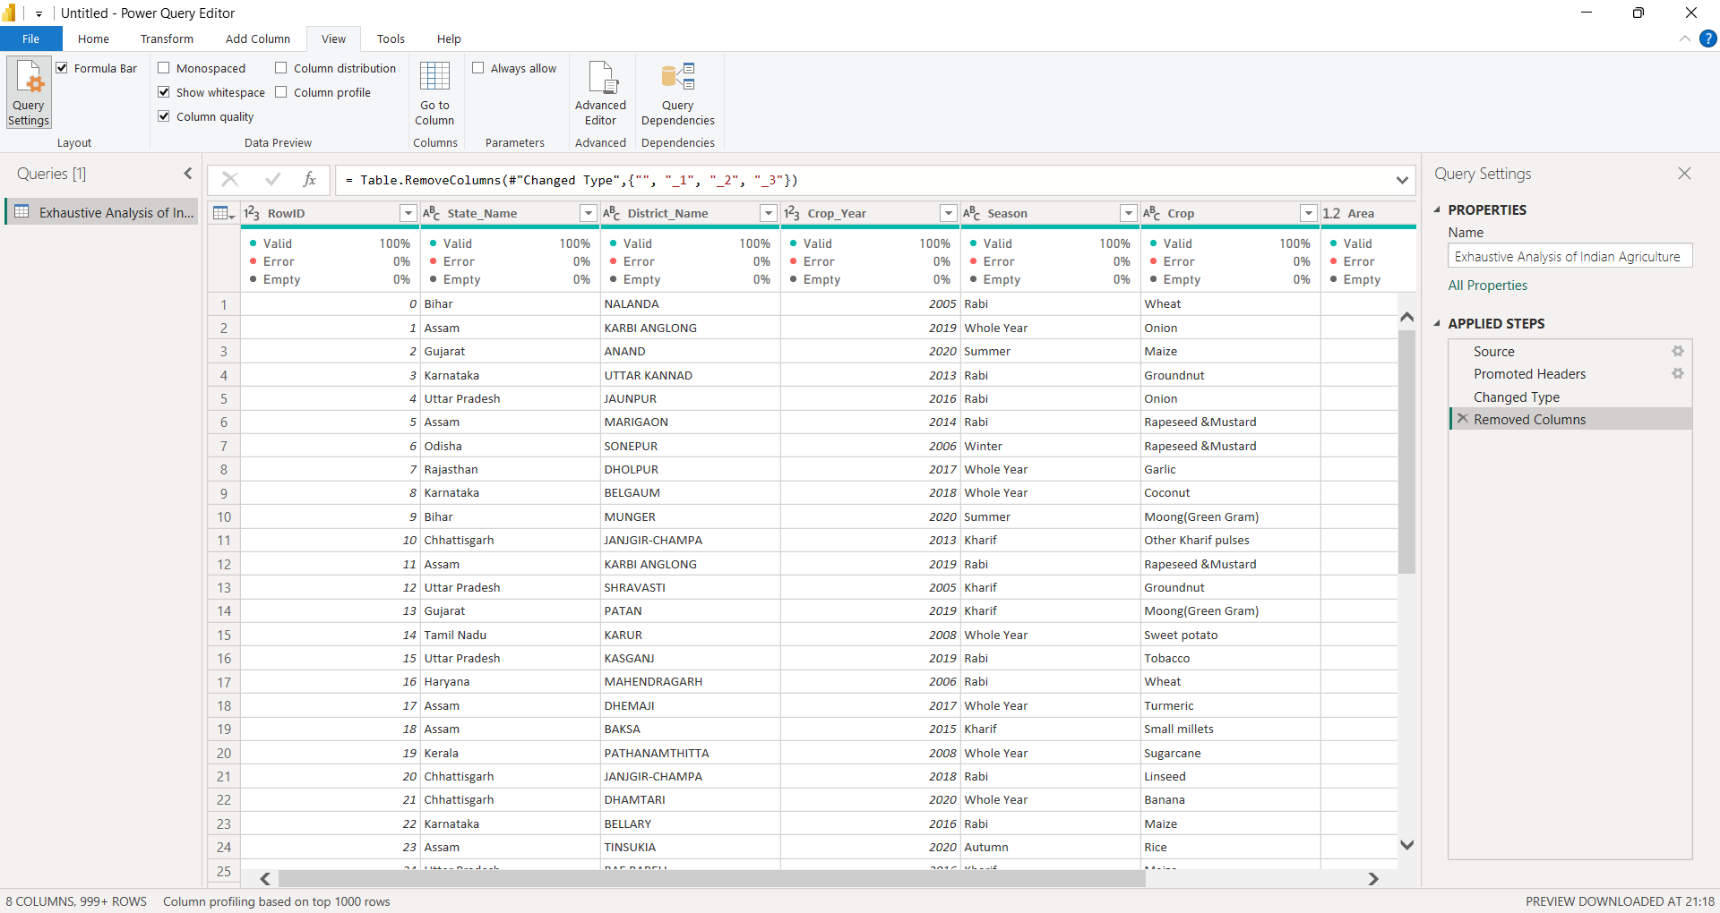

4. TO SAVE:

Click “home”-> close and apply -> close and apply -> click “table view” in the POWER BI DESKTOP. All the changes will be projected in the POWER BI DESKTOP.

